FTIR notes:

Bruker Vertex 70 FTIR KBr beamsplitter and MCT detector, analyze with OPUS software. GloBar MIR source.

For all measurements:

Add liquid nitrogen to the instrument to cool down the detector at least 20 minutes before taking a measurement.

**Making a KBR pellet:** 1 mg of compound with 100 mg of KBr.

Note: Make sure all your equipment is oven-dried. Take the clean and dry mortar and pestle and the Econopress parts (2 bolts and a barrel) out of the oven. Allow to cool to room temperature, and then use immediately.

1. **Use the mortar and pestle to finely grind the compound, then mix in the KBr.**
2. **Assemble the Econopress apparatus with the sample between the two bolts.** Insert one bolt into the barrel, and tap in enough of the KBr mixture to just cover the bottom of the bolt. Carefully and slowly screw the top bolt into the barrel, pressing the sample between the two bolts. Use a wrench to further tighten the bolts as much as possible. Wait a minimum of one minute, and then carefully and slowly loosen the bolts. The KBr pellet should be intact as a thin layer across the barrel.

FTIR operation:

**Open the OPUS software from the desktop. Select “Moore, G” as the user and enter the “N!tr0gen” password.** The circle at the bottom right of the software should be green. If it is not, click the circle to open the diagnostics. The two most common problems are that the detector is not cool, in which case more LN2 must be added, or that an instrument test must be run. A PQ test has to be done once a week, so if you encounter this just hit “run PQ test” and it will run through it for about 5 minutes and then give a test result. If everything is fine the circle will turn green and you can proceed.

For KBr sample:

1. **Insert the sample holder into the quick-lock mechanism**. The holder is usually assembled, if not there is a plate that quick locks into the machine, and then the sample holder is slid into the plate.
2. **Purge the sample chamber with LN2.** Open the two green valves on the large LN2 tank equally. There are 3 more valves that control the flow; check to make sure they are open and that the pressure is around 500 on the indicator to the left of the instrument. Purge the sample chamber of the FTIR for about 5 minutes or until you obtain a clean blank spectrum.
3. **Load experiment parameters.** Select “Measurement” and then “Advanced Measurement” at the top of the page. Load the experiment “standardparametersKbr.xpm” in the GFMoore folder. (C: drive>Documents>Data>GFMoore). This will load the standard parameters, but they can be changed by you if you want a different resolution, more scans, etc under the tab “Advanced Measurement”. Be sure to select the correct path for your files (the folder you want them in) or they will be saved to whoever used the instrument last.
4. **Run experiment.** Click the “Check signal” tab. The amplitude should be between 20000 and 25000. Go to “Basic measurement” and click “Background Signal Channel”. This will take the background, after which you can place your sample on the sample holder, wait a few minutes for the chamber to purge again, and click “Sample Signal Channel”. This will give you the sample spectrum.
5. **Save the data.** Your data will automatically be saved in the folder you chose, but to be plotted it must be in a *.dpt file. To do this, highlight the spectrum you want to save, go to File>Save File as> and on the “Format” tab, select dpt. You will have to designate the path again. This data file can then be opened in Excel.
6. **Turn off the LN2.**

GATR samples:

**\*\*\*\*\*\*\*The germanium crystal is very easily scratched. Be very careful and keep it covered when not in use. Be cautious and take your time putting samples on and off the crystal!\*\*\*\*\*\*\*\***

1. **Insert the VariGATR into the quick-lock mechanism**. Connect the VariGATR in the sample holder. You will hear a beep when it is connected. Extend the purge seal sleeves and tighten the screws.
2. **Purge the sample chamber with LN2.** Open the two green valves on the large LN2 tank equally. There are 3 more valves that control the flow; check to make sure they are open and that the pressure is around 500 on the indicator to the left of the instrument. Purge the GATR for about 5 minutes or until you obtain a clean blank spectrum.
3. **Clean the germanium crystal.** Use methyl ethyl ketone and a stream of nitrogen to clean the crystal. Don’t let the methyl ethyl ketone get all over the instrument; use a Kimwipe to catch it as you blow it off the crystal. If the crystal still looks dirty, use methyl ethyl ketone and a cotton ball to gently wipe it.
4. **Load experiment parameters.** Select “Measurement” and then “Advanced Measurement” at the top of the page. Load the experiment “standardparametersGATR.xpm” in the GFMoore folder. (C: drive>Documents>Data>GFMoore). This will load the standard parameters, but they can be changed by you if you want a different resolution, more scans, etc under the tab “Advanced Measurement”. Be sure to select the correct path for your files (the folder you want them in) or they will be saved to whoever used the instrument last.
5. **Run experiment.** Click the “Check signal” tab. The amplitude should be around 30000. Go to “Basic measurement” and click “Background Signal Channel”. This will take the background, after which you can place your sample CAREFULLY onto the crystal face. Using the pressure applicator to press the sample to make good contact with the crystal. (The pressure pads on the applicator need to be changed out occasionally. If they look worn replace them with the extras in the GATR box.) Click “Sample Signal Channel”. This will give you the sample spectrum.
6. **Save the data.** Your data will automatically be saved in the folder you chose, but to be plotted it must be in a *.dpt file. To do this, highlight the spectrum you want to save, go to File>Save File as> and on the “Format” tab, select dpt. You will have to designate the path again. This data file can then be opened in Excel.
7. **Turn off the LN2, cover the crystal with the cotton strip, and put the GATR back in the box.**

What are those peaks in my spectrum?

1. It’s important to have a good background spectrum that matches the environment in which you take your sample. Here is what the transmission spectrum of CO2 and water in the air look like:

The sharp double peak at 2400 is CO2, and the water features are between 4000-3500 and 2000-1400. Source: http://chemistry.oregonstate.edu/courses/ch361-464/ch362/irinstrs.htm

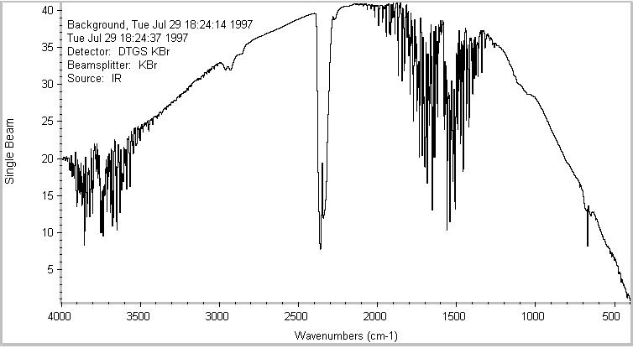

1. Methyl ethyl ketone residue from cleaning the GATR crystal shows up for up to 3 minutes after cleaning.

